**Lab Practical #06:**

Study the application layer protocol DNS, DHCP, FTP.

**Practical Assignment #06:**

1. **Implement the application layer protocol DNS, DHCP, and FTP. Also check connectivity between them using ping command or PDU utility.**
2. **DNS:**

The Domain Name System (DNS) is an application layer protocol that translates human-readable domain names into IP addresses that computers use to identify each other on the network.

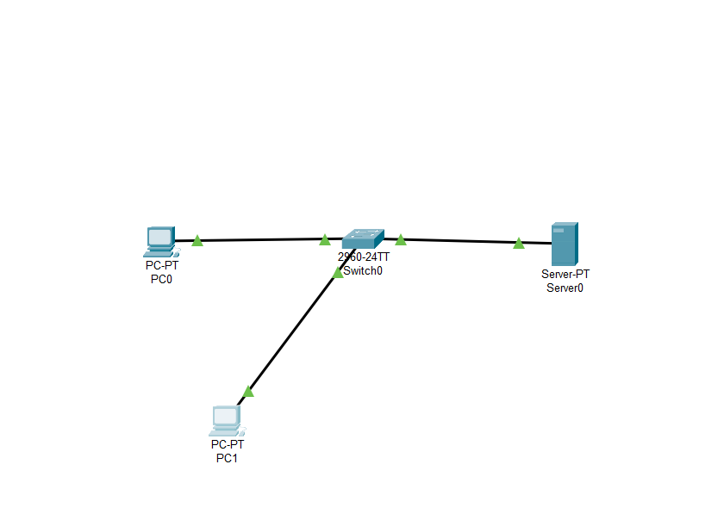

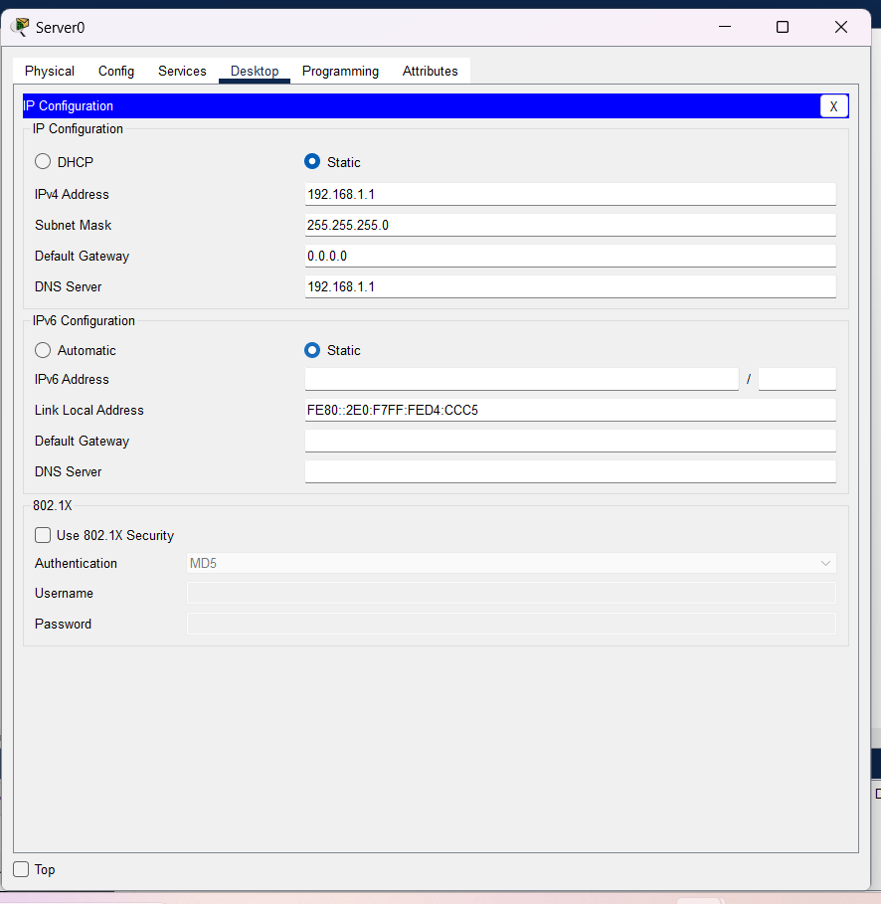

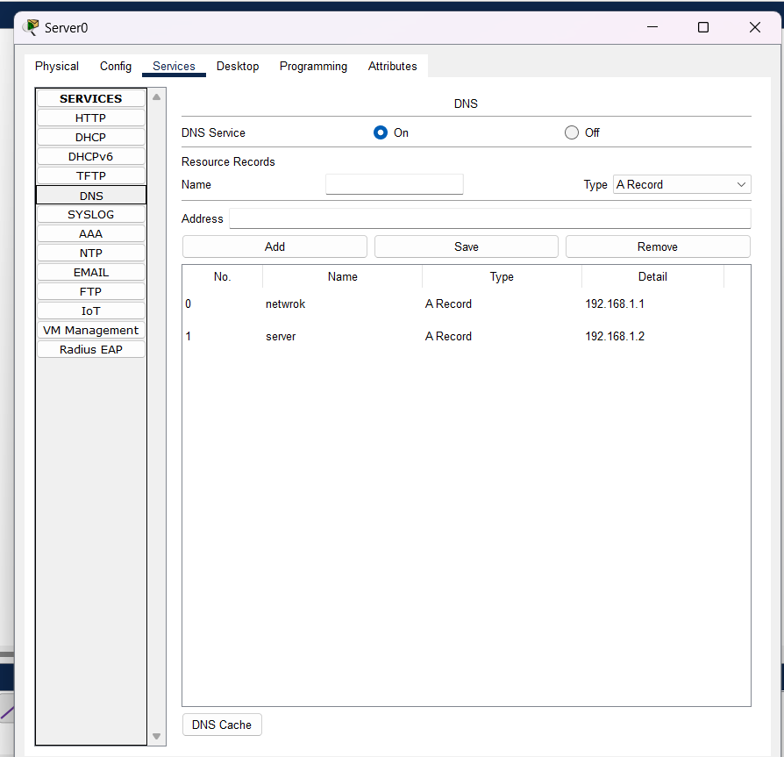

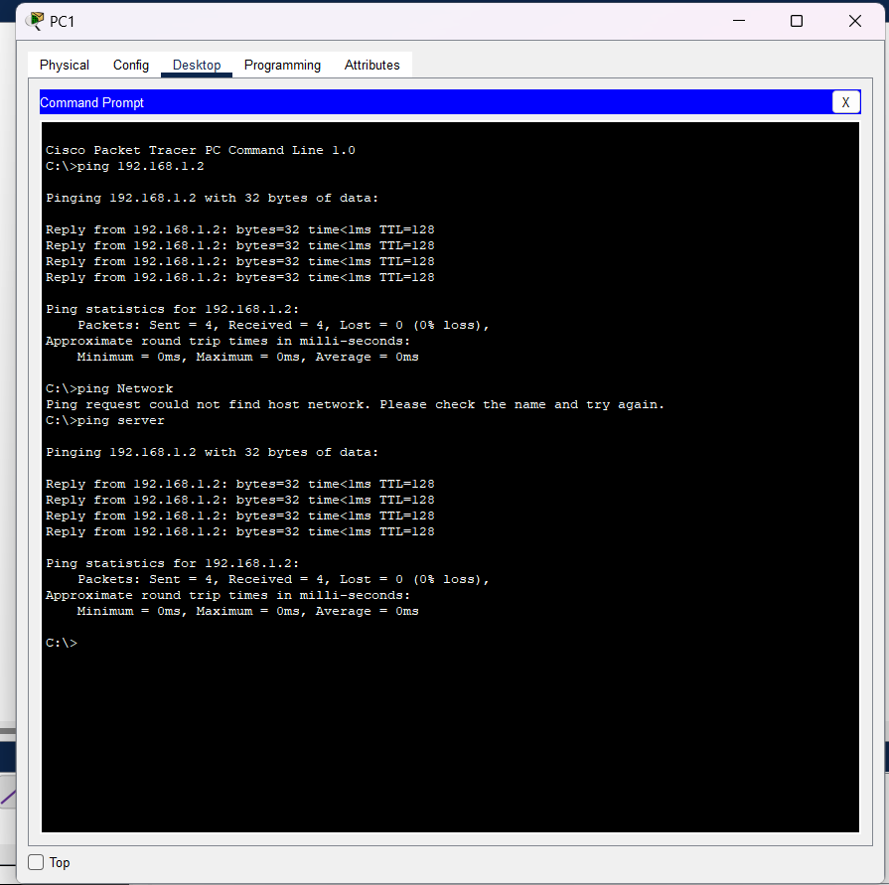

1. **DHCP:**

The Dynamic Host Configuration Protocol (DHCP) is an application layer protocol used for automating the assignment of IP addresses, subnet masks, default gateways, and other network configuration parameters to devices on a network.

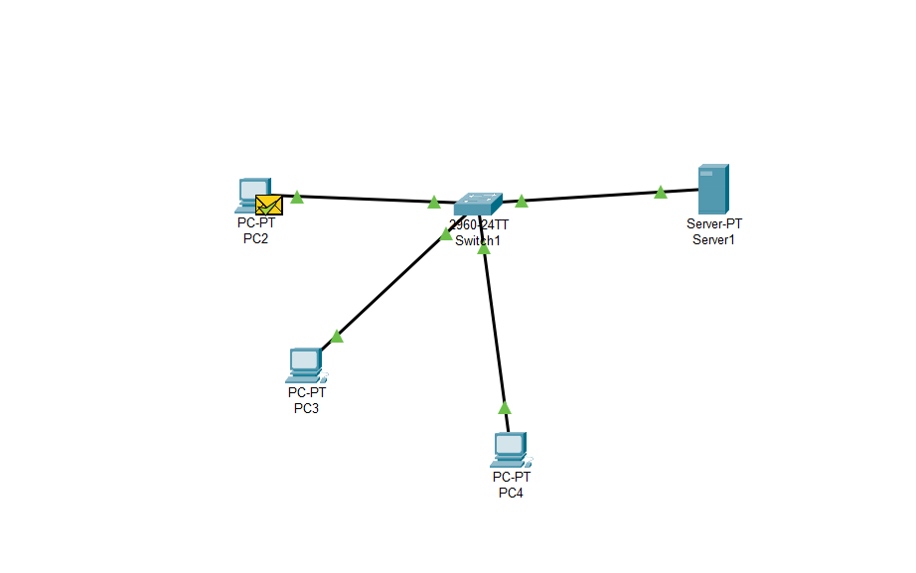

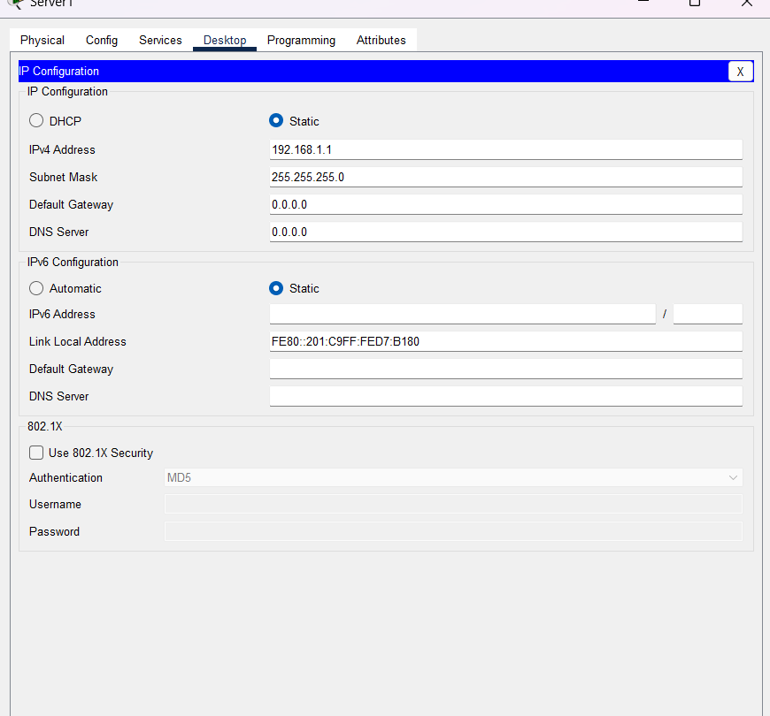

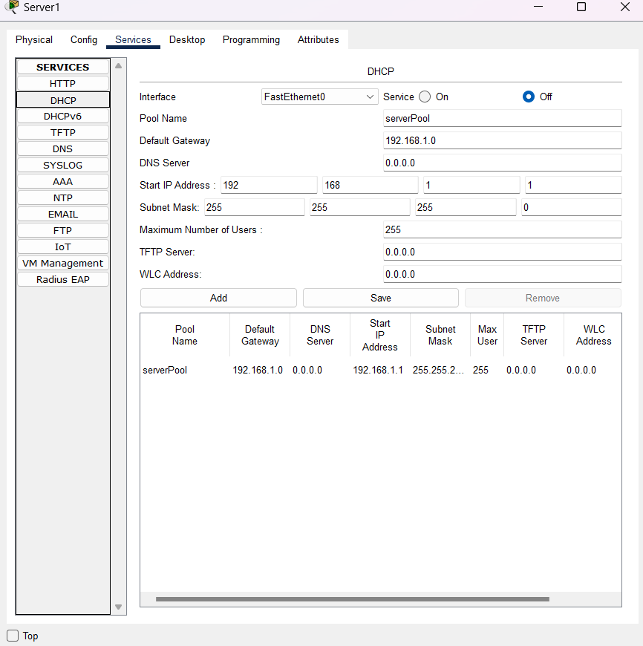

1. **FTP:**

The File Transfer Protocol (FTP) is an application layer protocol used for transferring files between a client and a server over a network.

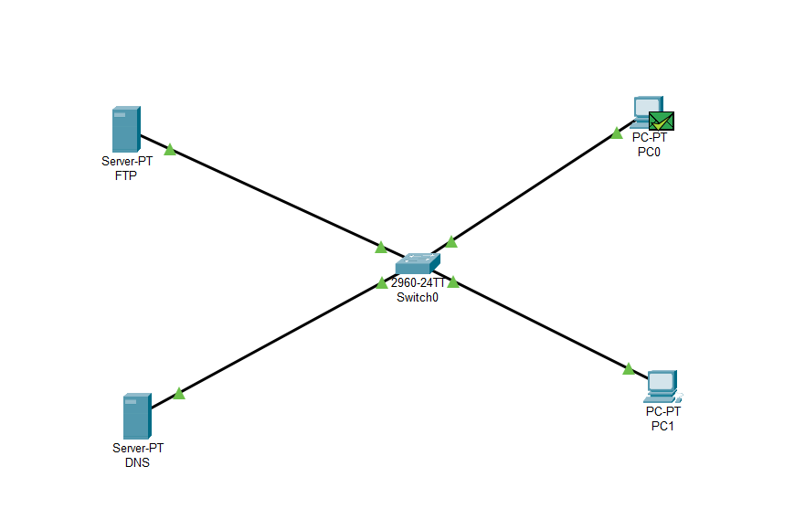

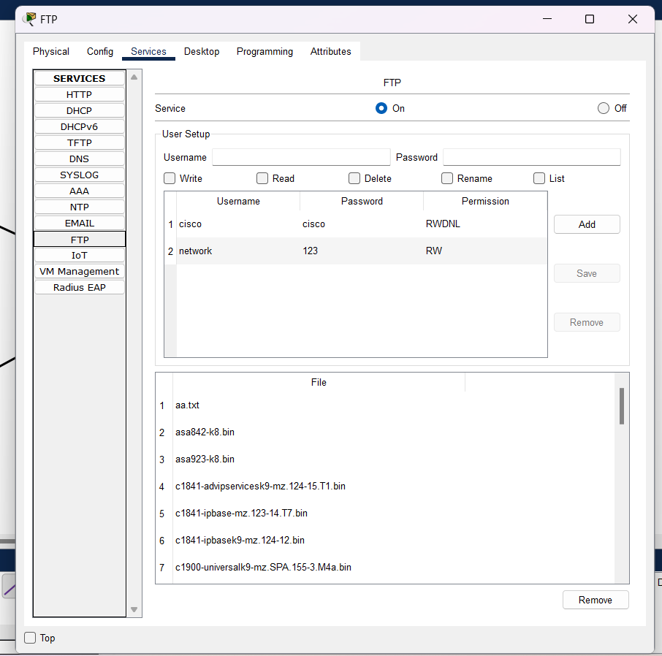

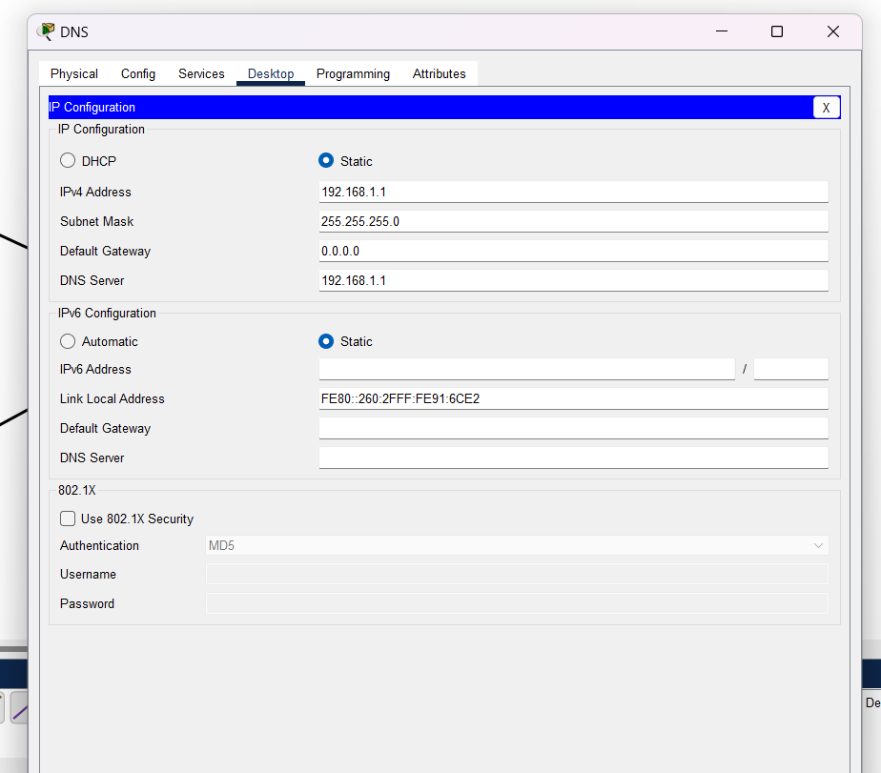

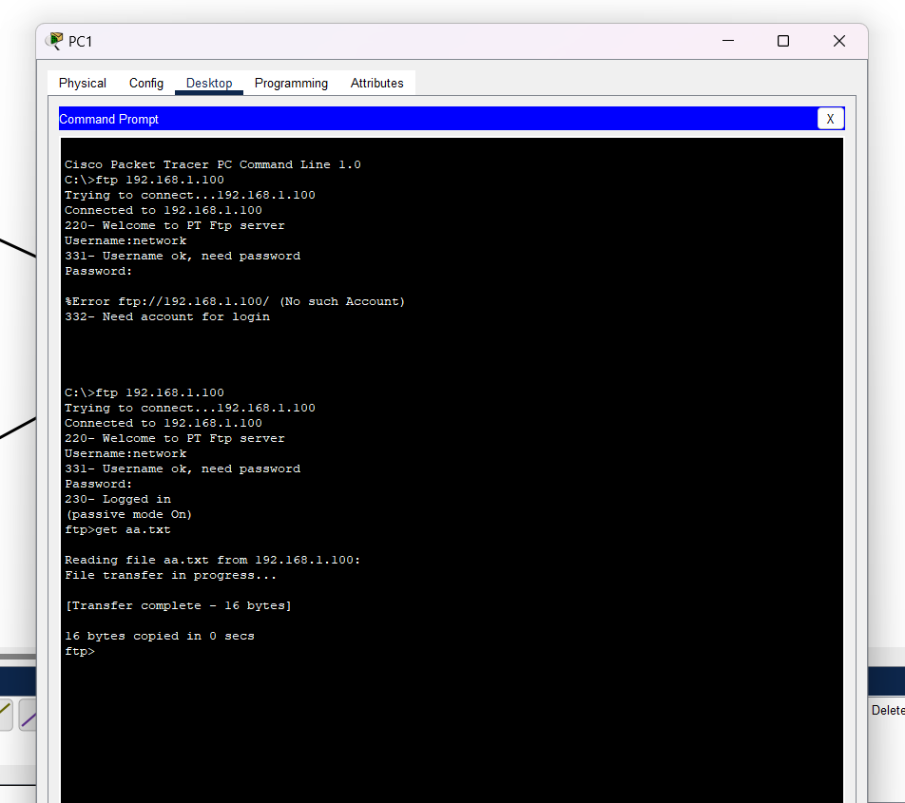

**Instructions:**

1. Protocol-wise configuration setup screenshot.
2. Mention IP address of each pc as label.
3. Ping command or PDU screenshot between two pcs.